**R Code for Examples in the book**

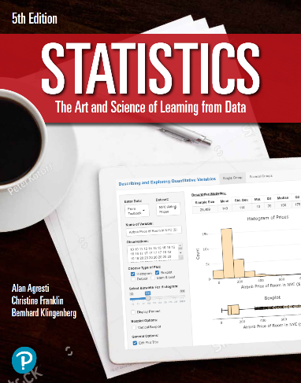

***“Statistics: The Art and Science of Learning from Data”***

**by Agresti, Franklin and Klingenberg, 5th edition**

**Chapter 11**

**Example 10: A Tea-Tasting Experiment – Fisher’s Exact Test**

## Reading in data

mytable <- as.table(matrix(c(3, 1, 1, 3), nrow = 2, byrow = TRUE,   
 dimnames = list(guess = c('milk', 'tea'),  
 actual = c('milk', 'tea'))))

## To perform a Fisher’s exact test

fisher.test(mytable)

##   
## Fisher's Exact Test for Count Data  
##   
## data: mytable  
## p-value = 0.4857  
## alternative hypothesis: true odds ratio is not equal to 1  
## 95 percent confidence interval:  
## 0.2117329 621.9337505  
## sample estimates:  
## odds ratio   
## 6.408309